Assignment 1

Tools / Software Required
- Microsoft Power BI Desktop
- Sample datasets: samplesuperstore.csv

Conduct
Part A: Data Acquisition

Step 1: Launch Power BI Desktop and import the CSV file.

Home > Get Data > Text/CSV
Browse to samplesuperstore.csv > Load
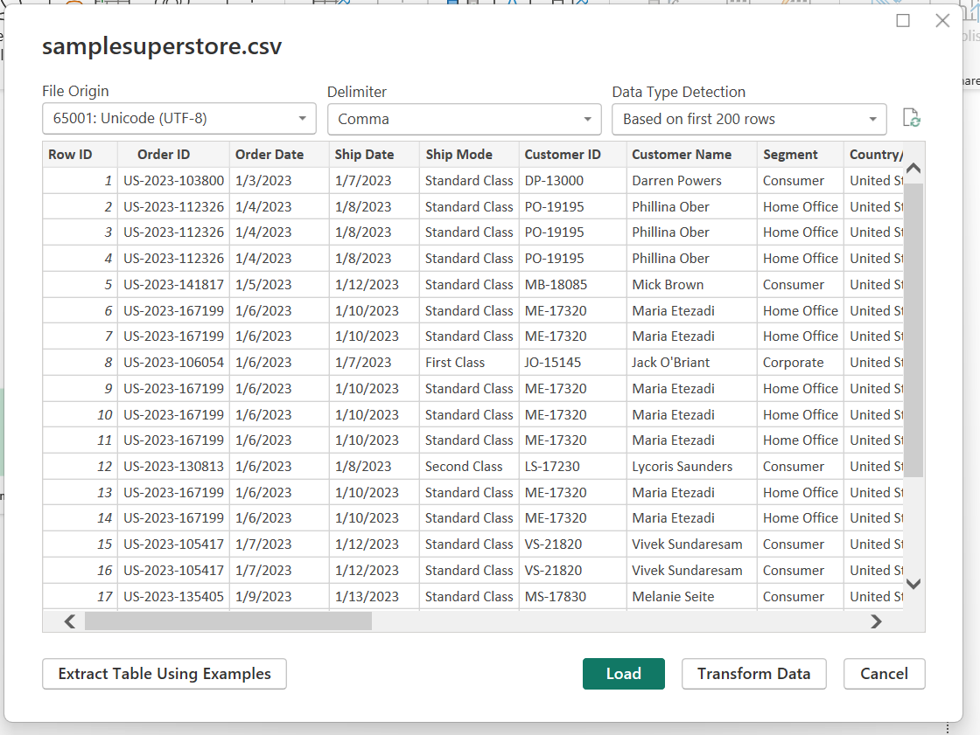

Part B: Transform – Power Query Editor
Step 4: Open Power Query Editor.
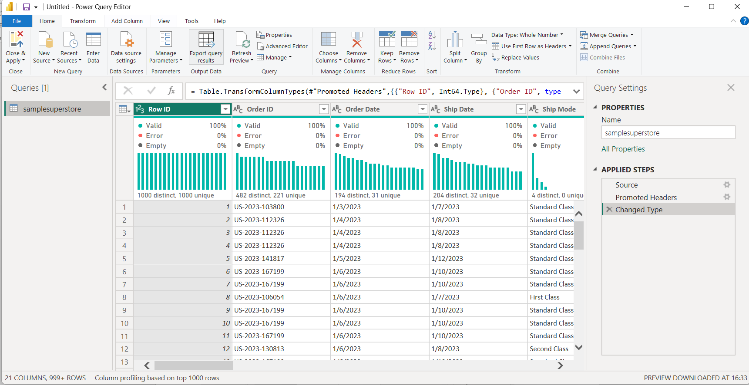
Step 5: Apply the following transformations to the Orders table:
• Remove duplicate records
• Remove blank rows
• Verify and correct data types
• Rename columns where required
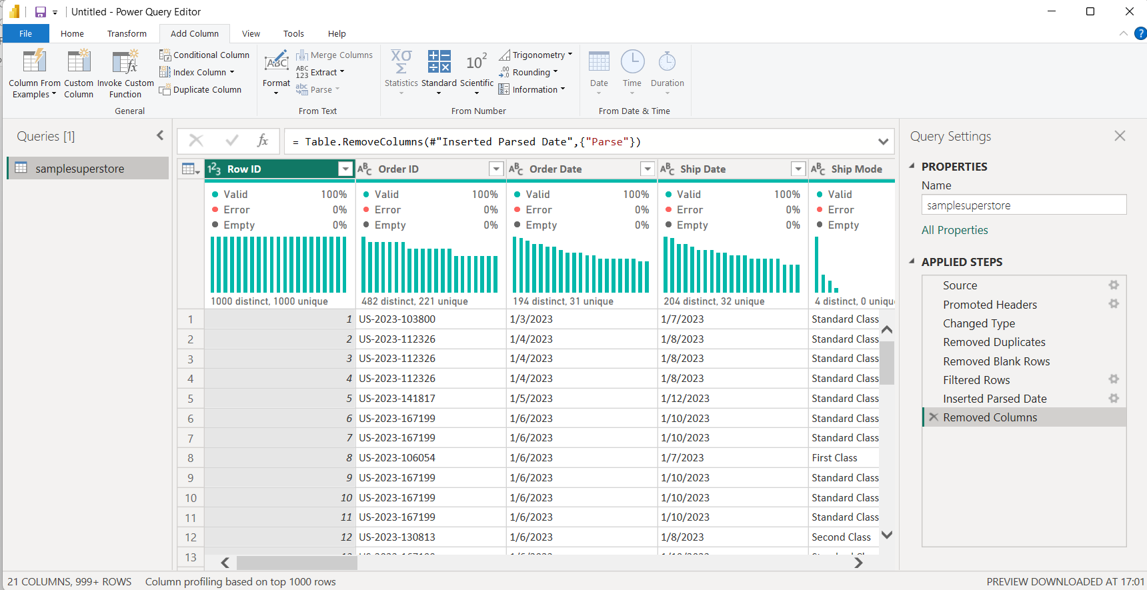

Part C: Load – Build Data Model
Step 10: Navigate to Model View.
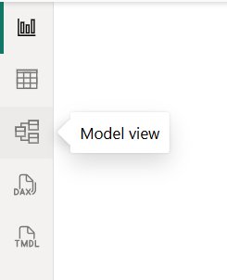
Step 6: Create DAX measures:
Total Sales = SUM('samplesuperstore'[Sales])
Total Profit = SUM('samplesuperstore'[Profit])
Average Sales = AVERAGE('samplesuperstore'[Sales])
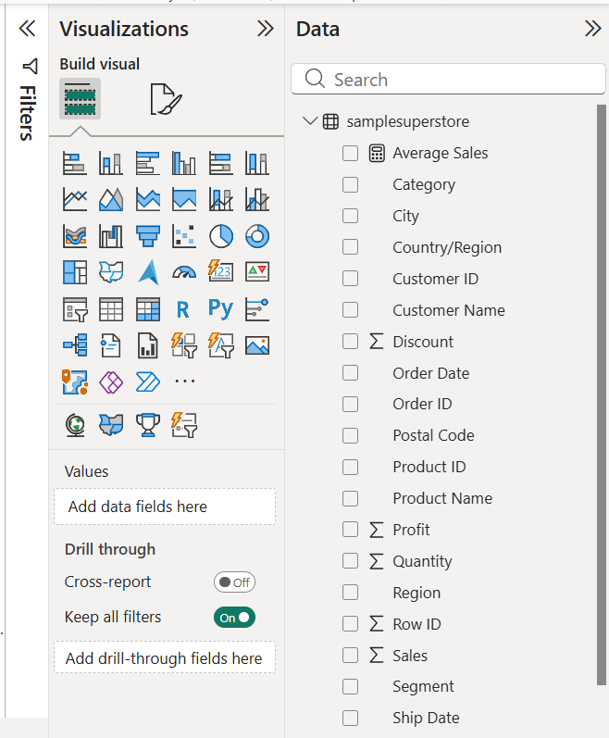
Step 7: Create a simple report visual using fields from related tables.
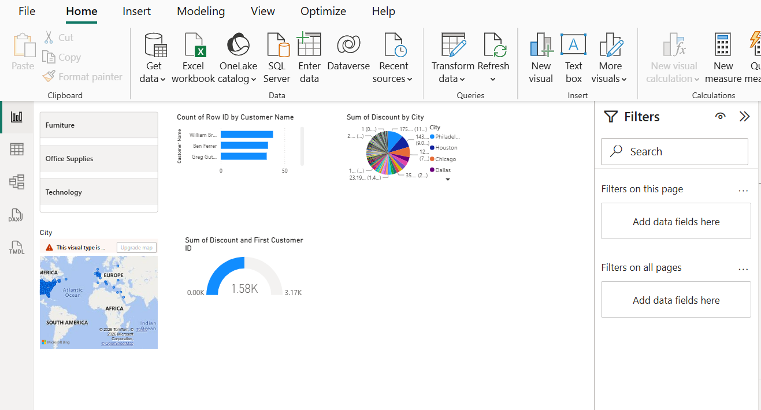

Part D: Foundational Analytical Canvas
Step 6: Establishing primary visualizations as the baseline for interactive OLAP operations
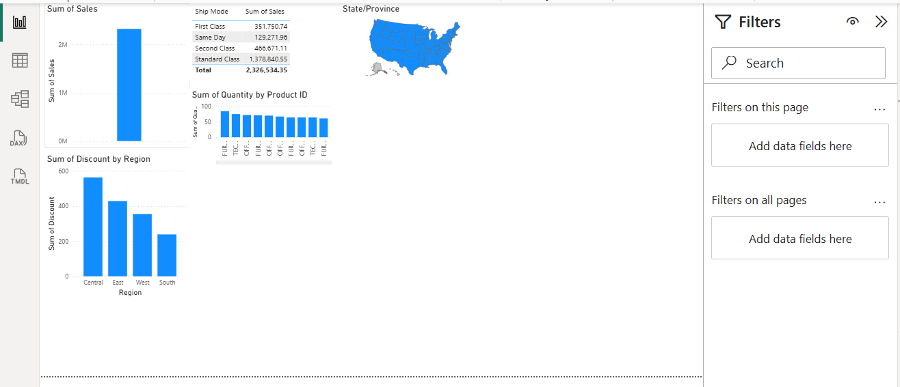

Step 7:Executing a Slice Operation
First, add a Slicer visual to your
report canvas.

Next, drag the 'Region' field into this
slicer.

And select the 'West' option.

Finally, observe the dynamic
changes across your Sales, Profit,
and Orders visuals.
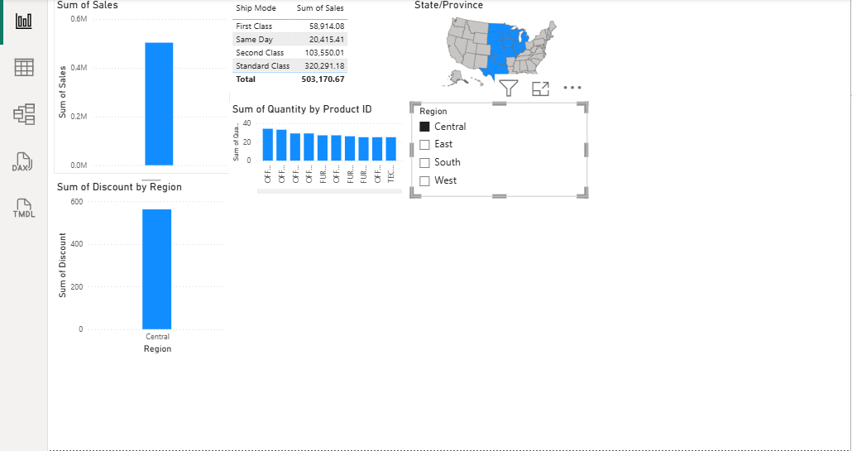

Result: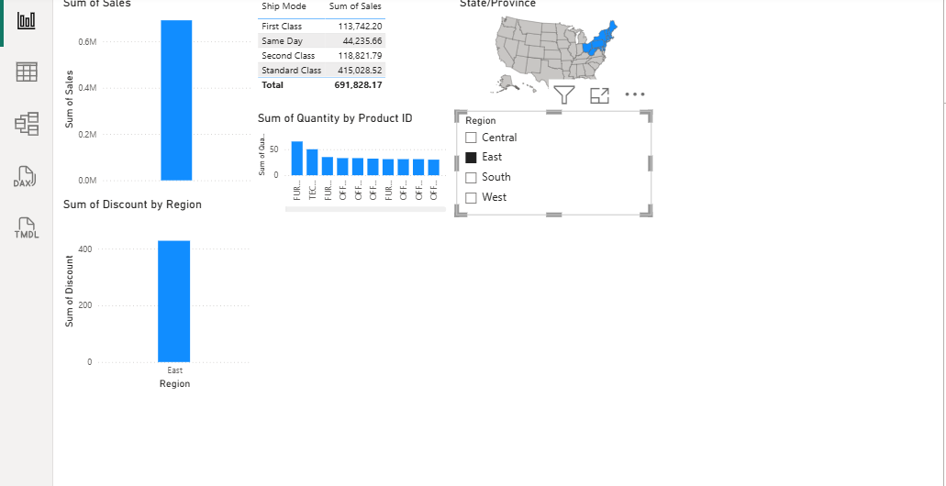
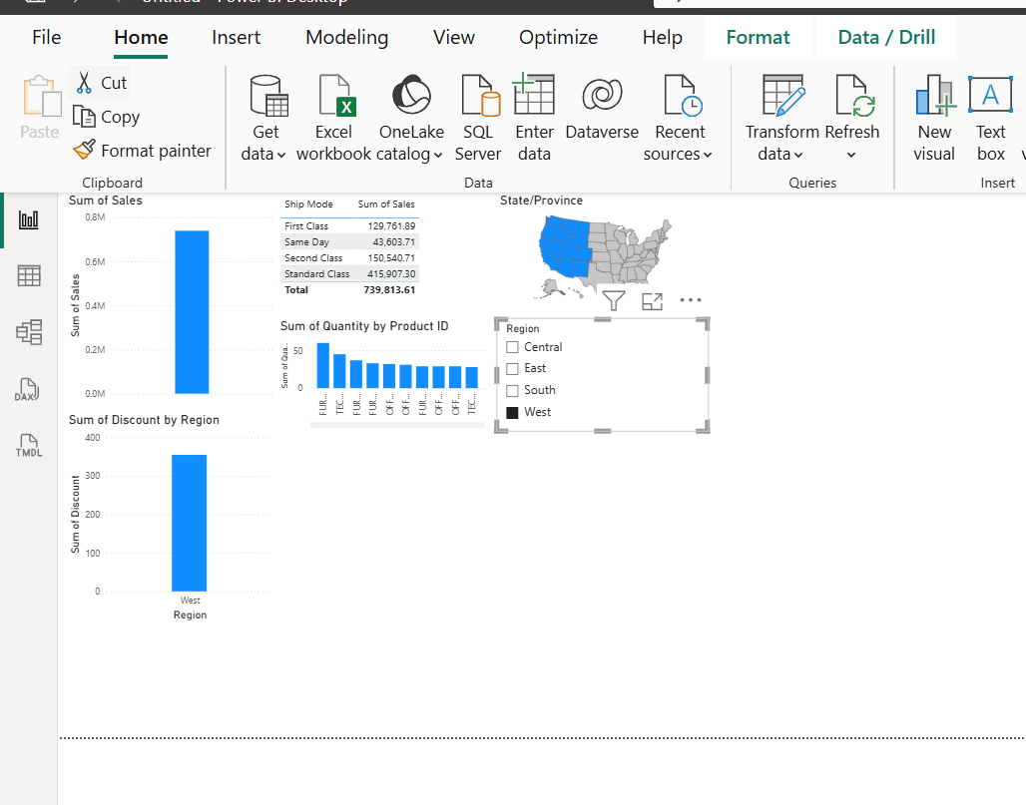
Data from multiple heterogeneous sources (CSV, Excel, and SQL database) was successfully acquired and imported into Microsoft Power BI Desktop. Data profiling was performed using the Power Query Editor's built-in tools — Column Quality, Column Distribution, and Column Profile. Key data quality dimensions including completeness, uniqueness, and validity were assessed across all datasets, and data quality issues were identified and documented for remediation prior to analysis.

